Webinar report
‘Cities and Forced Displacement from the Perspectives of the Global South and Global North’

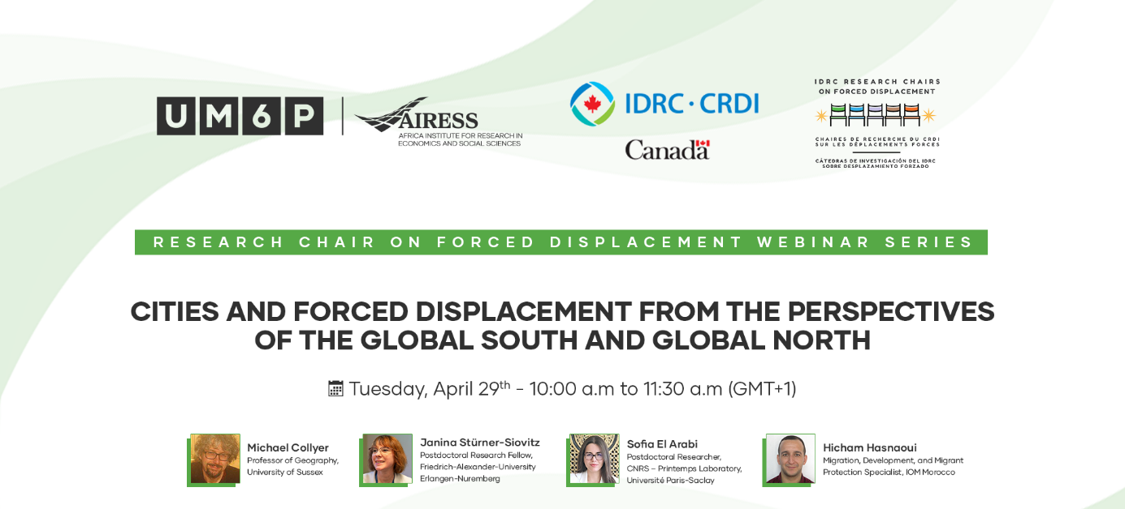

On 29 April 2029, the opening session of the UM6P Research Chair on Forced Displacement’s 2025 Webinar Series explored how cities across the Global South and Global North experience and respond to forced displacement. While urban areas host the majority of displaced populations, local authorities often operate with limited mandates and resources, yet remain at the frontlines of reception, protection, and inclusion.

To introduce the webinar topic, Prof. Michael Collyer (University of Sussex) participated in a podcast conversation with Prof. Myriam Cherti. Drawing on decades of research in diverse regions, Collyer reflected on the commonalities and differences in how cities respond to displacement. In addition, a scene-setting brief was published ahead of the webinar discussion.

Moderated by Prof. Myriam Cherti, IDRC Research Chair on Forced Displacement at UM6P, the session featured:
- Prof. Michael Collyer (University of Sussex) outlined key literature that has informed his research on cities and displacement and highlighted the historical and political significance of secondary cities in migration governance.
- Dr. Janina Stürner-Siovitz (Friedrich-Alexander University of Erlangen-Nuremberg) presented findings from a multi-country research project on intermediary cities in Africa, showing how local governments engage in multi-stakeholder partnerships to overcome limitations that result from lack of formal mandates to address urban migration and displacement.
- Dr. Sofia El Arabi (CNRS – Printemps Laboratory, Université Paris-Saclay) explored how secondary cities in Morocco respond to the displacement of sub-Saharan migrants within the context of externalized European border security. She highlighted and analysed Morocco’s internal dispersal strategy and foregrounded migrants’ active role in shaping urban inclusion.
- Hicham Hasnaoui (IOM Morocco) provided an overview of migration dynamics in North Africa and IOM’s work on urban integration in Moroccan cities through the implementation of the Urban Diagnostic Tool (UDT). He also highlighted and analysed the role of national and local authorities, municipalities, and regions in strengthening migration governance.

The webinar and podcast informed the policy brief, which synthesises these insights into concrete policy recommendations. The brief calls for (1) recognising urban actors as key actors in migration governance; (2) investing in inclusive urban planning, housing, and social cohesion; (3) strengthening coordination between local, national, and regional actors; and (4) integrating the voices of migrants, research, and grassroots initiatives in policymaking.

